**뷰의 작성**

1. **Select * from sample54;**
2. **Select * from sample_view_67;**
3. **Create view sample_view_67 as select a from sample54;**
4. **Select * from sample_view_67;**

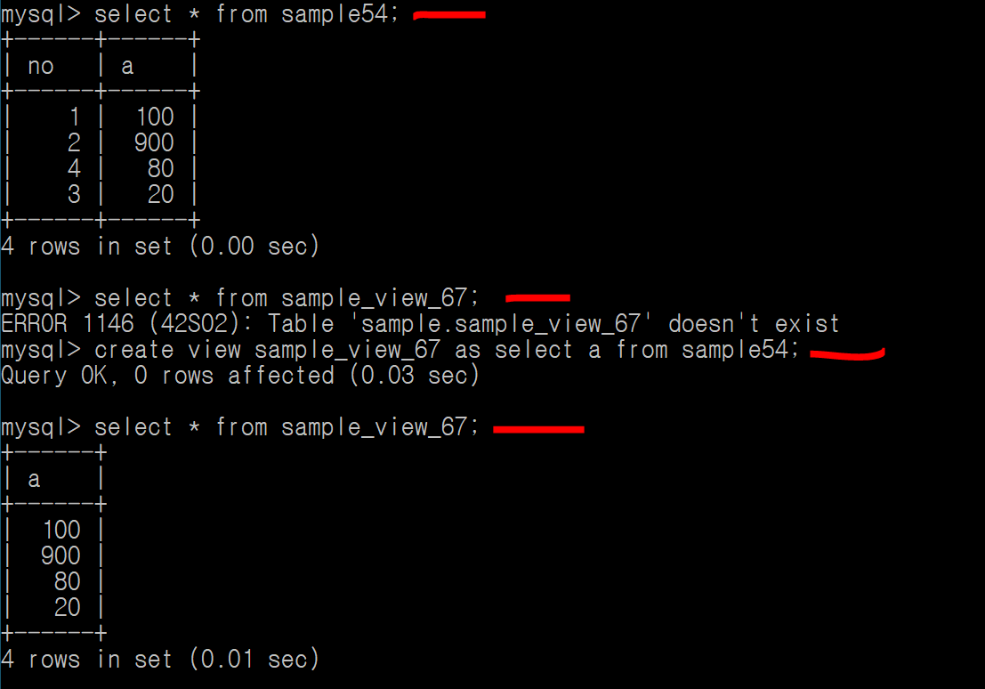

**Select a from sample54의 결과를**

**Select_view_67로 객체를 만들어버렷;**

1. **Create view sample_view_672(N,V,V2)**

**as select no,a,a*2 from sample54;**

1. **Select * from sample_view_672;**

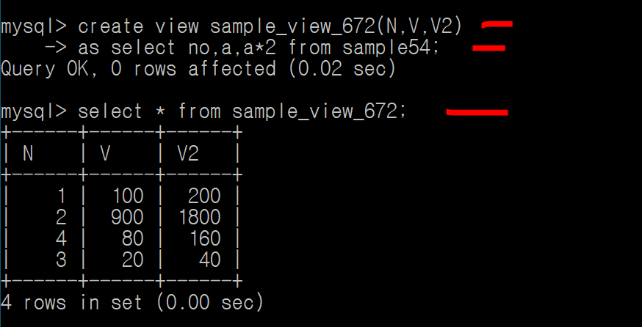

**열 이름을 지정하여 뷰를 만들수도 있음!**